PROJECT FALCON-01
Design and Development of a Solar-Powered Smart Coastal Observation Buoy with Shore-Based AI for Near-Real-Time Coastal Monitoring and Short-Term Wave-Height Prediction
V3.7 — SHORE BAY STATION + LTE/CELLULAR + AI PREDICTION ARCHITECTURE
Undergraduate Thesis Documentation
30 August 2026

Executive Summary
Project FALCON-01 is a low-cost, modular, solar-powered smart coastal observation buoy designed for near-real-time coastal monitoring. The revised architecture separates the low-power buoy sensing node from a shore-based Bay Station. The buoy contains only the ESP32 controller, approved sensors, LTE/cellular telemetry hardware, battery/solar power subsystem, and security electronics. It does not contain a mini PC. Validated telemetry is transmitted through an available cellular data network to a shore-based Bay Station, where a mini PC performs database storage, pressure-based wave processing, REST API services, dashboard hosting, alert management, and AI-based short-term wave-height prediction.
The Phase 1 study uses a Blue Robotics Bar02 or compatible waterproof pressure sensor as the primary wave input. The device directly measures underwater pressure variation. Software preserves raw pressure, filters noise, establishes a documented baseline, and converts the dynamic pressure component into an estimated wave-height value. The project therefore uses the wording pressure-based estimated wave height and does not claim that the pressure sensor directly measures laboratory-grade wave height.
The buoy uses passive mooring with adequate line scope for tides and normal wave motion. Security is provided by persistent GPS geofence monitoring, a vibration/tamper input, an enclosure reed or limit switch, and a local buzzer. All higher-compute functions are relocated to a shore-based Bay Station. A mini PC at the Bay Station performs data processing, storage, visualization, and AI prediction, reducing continuous onboard power demand, waterproofing complexity, heat generation, and maintenance difficulty. Core sensing and local security functions continue on the ESP32 even when the Bay Station or Internet link is temporarily unavailable.

1. Project Background
The Philippines has extensive coastlines that support fisheries, transport, tourism, education, environmental research, and community livelihoods. Localized coastal conditions can differ from broader forecasts, yet continuous observation equipment may be difficult for small schools and communities to acquire and maintain. Commercial oceanographic buoys provide professional measurements but can involve high cost, proprietary systems, specialized servicing, and infrastructure beyond the resources of an undergraduate project.
Affordable microcontrollers, LTE/cellular telemetry modules, shore-based mini PCs, solar components, and open-source software make it possible to investigate a practical split architecture. FALCON uses an ESP32 as a low-power onboard acquisition controller while a shore-based Bay Station mini PC provides storage, processing, visualization, alerting, and AI-based short-term wave-height prediction. This arrangement reduces the energy burden on the buoy and allows compute performance, storage, and AI capability to be upgraded without redesigning the marine sensing node. Its purpose is educational and research-oriented monitoring, not replacement of professional oceanographic instruments or official agencies.

2. Statement of the Problem
Many low-cost monitoring prototypes demonstrate sensors and dashboards but do not provide a complete serviceable platform that combines traceable pressure-based wave estimation, local environmental data, power autonomy, local data retention, and basic anti-theft/tamper awareness. The study asks whether these functions can be integrated and evaluated within an affordable undergraduate prototype while clearly distinguishing measured, estimated, simulated, stale, and uncalibrated data.
1. How can a low-cost solar-powered buoy acquire and transmit near-real-time coastal measurements using an ESP32 while relocating database, processing, and dashboard services to a shore-based Bay Station?
2. How accurately and repeatably can calibrated underwater-pressure variation be processed into an estimated wave-height signal under controlled conditions?
3. How reliably can GPS geofence, vibration/tamper, and enclosure-access rules detect persistent security events without being triggered by normal wave movement?
4. How clearly can a simplified four-page dashboard hosted at the Bay Station communicate wave, environment, GPS, power, security, health, and alert information with minimal navigation for non-technical users?
5. How does the prototype perform in sensor accuracy, cellular communication reliability, outage recovery, dashboard usability, onboard energy use, data retention, and system recovery?
6. How accurately can a Bay Station AI model predict short-term wave height from recent validated buoy observations compared with a documented non-AI baseline?

3. Research Gap and Proposed Novelty
Existing low-cost IoT studies frequently emphasize acquisition and display, while professional platforms emphasize calibrated accuracy at substantially greater cost. A practical gap remains for an open, modular educational architecture that combines a low-power marine sensing node, pressure-based wave estimation, solar autonomy, LTE/cellular telemetry, shore-based processing, local institutional data retention, serviceability, basic security monitoring, and evaluated short-term AI wave-height prediction for controlled Philippine coastal trials.
FALCON does not claim to invent pressure sensing, GPS geofencing, cellular telemetry, or wave science. Its proposed novelty is the transparent integration and evaluation of these established technologies in a split buoy-to-Bay-Station architecture. The buoy focuses on sensing, local security, temporary buffering, and reliable telemetry, while the Bay Station mini PC performs storage, calibrated wave processing, visualization, alerting, and short-term AI wave-height prediction. The study will report calibration state, prediction error, network availability, limitations, and actual test evidence rather than presenting planned hardware or simulator output as completed field performance.

4. Objectives

4.1 General Objective
To design, develop, and evaluate a low-cost solar-powered smart coastal observation buoy that provides real-time coastal monitoring, pressure-based estimated wave height, and shore-based AI short-term wave-height prediction through an ESP32 sensing node, LTE/cellular telemetry link, Bay Station mini PC, and responsive web dashboard.

4.2 Specific Objectives
1. Integrate pressure, GPS, wind, environmental, power, system-health, and security channels using documented interfaces and calibration states.
2. Develop a traceable pipeline that retains raw and filtered pressure, baseline, optional depth, estimated wave height, validity, timestamp, and calibration metadata.
3. Implement persistent/debounced geofence, tamper, and enclosure security rules with SECURE, WARNING, ALERT, and DISARMED states.
4. Implement LTE/cellular telemetry from the buoy to a shore-based Bay Station mini PC, with validated ingestion, SQLite storage, REST API, logs, alerts, temporary outage buffering, and automatic recovery when connectivity returns.
5. Develop a responsive dashboard with Overview, Buoy Motion, Sensors, and Logs & Alerts as four primary navigation pages, including a clearly separated Actual/Estimated wave-height trend and AI short-term prediction view.
6. Develop and evaluate an AI model for short-term wave-height prediction using recent validated buoy observations, compare it with a documented baseline, and report MAE, RMSE, prediction horizon, and held-out test performance.

5. Scope and Delimitations
Phase 1 covers a single near-shore prototype, passive single-anchor mooring, ESP32-based onboard acquisition, LTE/cellular data telemetry, pressure-based estimated wave height, core/supporting environmental readings, onboard power monitoring, basic security, short-term outage buffering, and a shore-based Bay Station mini PC that hosts processing, storage, API services, the browser dashboard, alerts, and AI short-term wave-height prediction. The buoy itself contains no mini PC. The exact final mini PC and cellular modem are subject to component approval.
The study does not provide official weather, storm, typhoon, tsunami, navigation, or emergency warnings. It does not claim laboratory-grade water-quality analysis, professional oceanographic accuracy, autonomous navigation, guaranteed uninterrupted Internet service, satellite communication through an unsupported modem, camera AI, or multi-buoy operation. Cellular provider selection depends on deployment-site coverage. Satellite-to-mobile connectivity may be considered only as a fallback where service and device/modem compatibility are verified. AI is limited to short-term wave-height prediction and shall not be presented as storm, typhoon, tsunami, or emergency prediction.

6. System Architecture

Figure 1 summarizes the revised split architecture requested during adviser consultation. The marine buoy is strictly a low-power sensing and telemetry node containing the ESP32, sensors, LTE/cellular modem, battery/solar subsystem, and security electronics. No mini PC is installed on the buoy. The shore-based Bay Station mini PC performs telemetry ingestion, storage, pressure-based wave estimation, AI short-term wave-height prediction, REST API/dashboard services, and alert management.

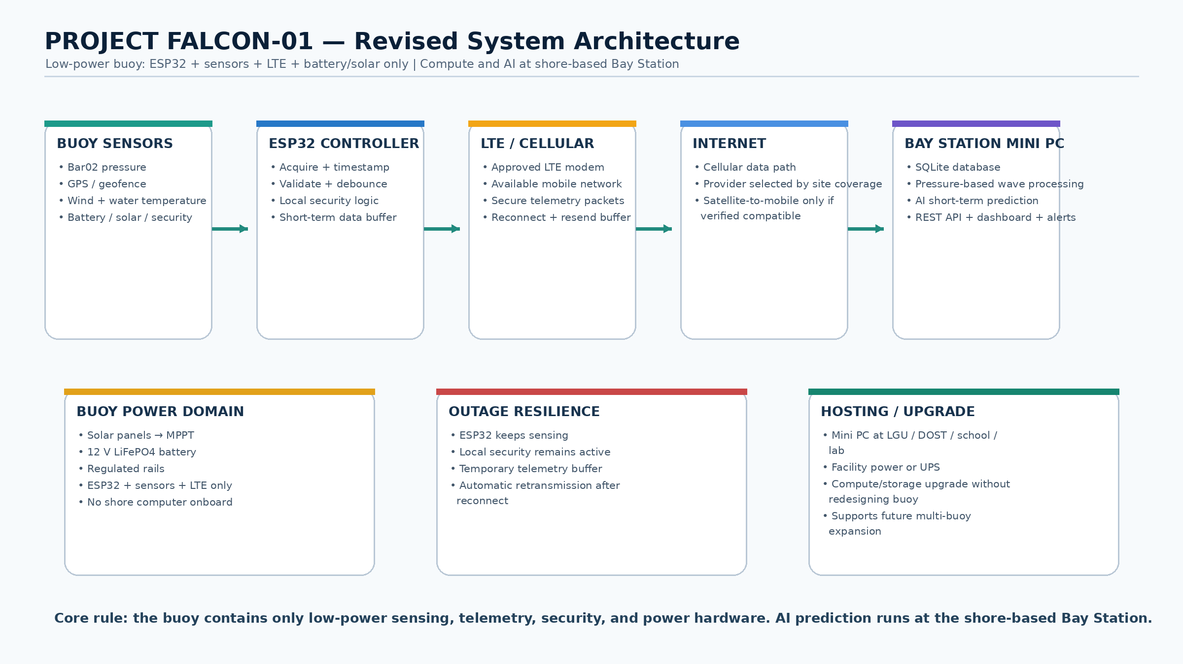

Figure 1. Revised Project FALCON-01 buoy-to-Bay-Station system architecture and cellular telemetry flow.
Layer | Primary responsibility | Failure behavior
Buoy sensors and interfaces | Produce raw pressure, GPS, wind, environment, power, and security signals | Invalid/unavailable values are reported, not replaced by zero
ESP32 buoy controller | Acquire, timestamp, validate, debounce, apply calibration, run local security logic, frame telemetry, and buffer short outages | Continues sensing/security if cellular or Bay Station link is unavailable
Cellular telemetry | Transmit validated packets through an available mobile data network; provider selected by deployment coverage | Reconnect and retransmit buffered records; satellite-to-mobile only if compatible/available
Shore-based Bay Station | Mini PC receives telemetry, stores records, estimates waves, runs short-term AI prediction, serves API/dashboard, and manages alerts | Services restart automatically; received records preserved where possible; AI output marked unavailable if inputs are stale
Dashboard / AI Prediction | Display current state, grouped sensors, logs/alerts, motion view, historical wave data, and short-term AI prediction | Shows STALE/OFFLINE when telemetry stops; prediction is withheld if input quality is insufficient

7. Hardware Components
Group | Component | Purpose and status
Core | Bar02 or compatible pressure sensor | Raw pressure and calibrated estimated wave height; selected family
Core | GPS receiver | Position, time, fix quality, geofence; exact model TBD
Core | Wind speed/direction | Local wind context; exact models TBD
Supporting | Sealed DS18B20 | Water temperature; reference comparison required
Health | Battery, solar, enclosure temperature | Energy and electronics health; exact interfaces verified before fabrication
Security | GPS geofence, tamper input, enclosure switch, buzzer | Debounced/persistent anti-theft awareness; exact hardware TBD where stated
Controller | ESP32 DevKit | Deterministic sensor acquisition, validation, buffering, and versioned telemetry framing
Bay Station | Shore-based mini PC (exact model TBD) | Database, pressure processing, AI prediction, REST API, dashboard, alerts; facility powered
Exact datasheets, logic voltages, connector pinouts, footprints, cellular modem/SIM requirements, antenna placement, current requirements, and environmental ratings must be verified before final PCB release. The mini PC is exclusively a shore-based Bay Station component and is never part of the buoy power or waterproof enclosure design.

7.1 Water Temperature Monitoring
FALCON includes a sealed DS18B20 supporting sensor that reports water temperature in degrees Celsius. This channel provides environmental context and does not constitute laboratory-grade water-quality analysis.
Channel | Required output | Validity and calibration rule
Sealed DS18B20 | Water temperature (°C), timestamp, validity, and freshness | Compare with a traceable reference thermometer; report OFFLINE or STALE when invalid
The dashboard displays this channel under Water. Exact model identification, sampling, freshness, validity, and reference-comparison status remain available in expanded technical details.

8. Pressure-Based Wave Estimation Method

The pressure-based wave method is treated as an estimation and validation pipeline rather than a direct wave-height measurement. The following flow defines the required processing and evidence path.

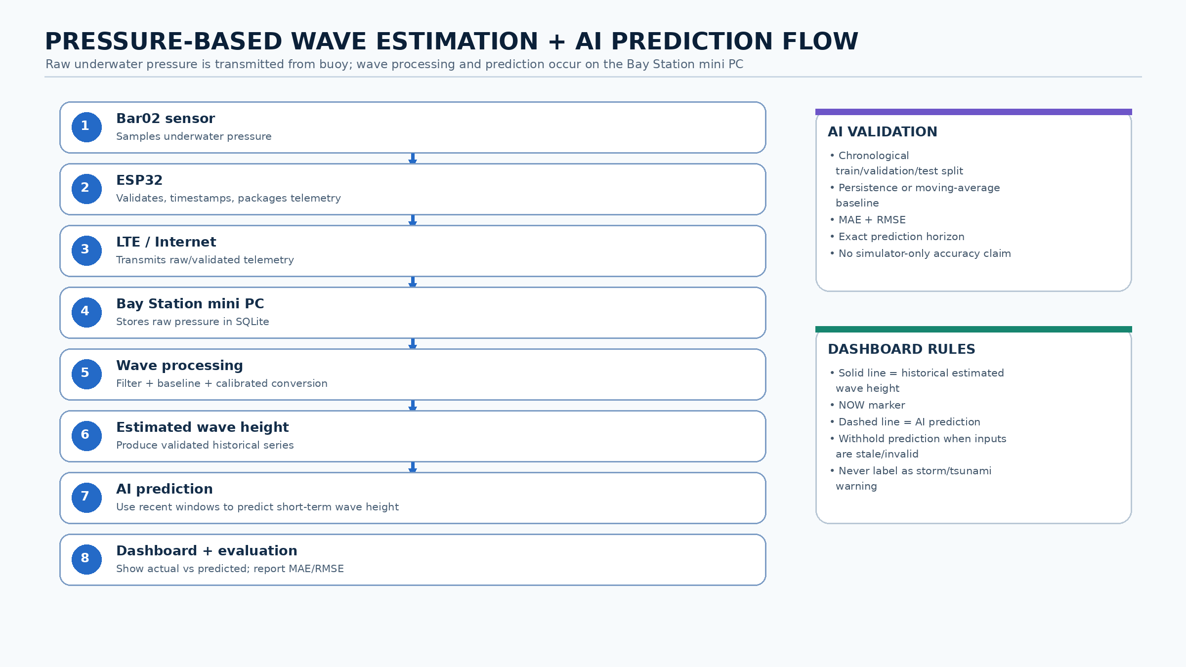

Figure 2. Detailed pressure-based wave-height estimation and reference-validation flow.
1. Read timestamped raw underwater pressure in documented engineering units.
2. Reject missing, out-of-range, disconnected, or stale samples while retaining diagnostic reasons.
3. Apply a documented low-pass/band-pass or equivalent filter selected through controlled data analysis.
4. Establish a pressure baseline at a measured installation depth and record temperature and calibration conditions.
5. Isolate the dynamic pressure variation associated with water-surface motion.
6. Apply the documented hydrostatic/dynamic conversion and calibration coefficient to estimate wave height.
7. Report estimated wave height, quality/validity, timestamp, source, baseline, and calibration state.
8.1 Bay Station AI Short-Term Wave-Height Prediction
The AI component is a core Bay Station function and is not executed on the buoy. After calibrated pressure data are converted into a time-ordered estimated wave-height series, the mini PC constructs fixed observation windows from recent valid samples and supporting contextual variables that are actually available in the final sensor set. The target is a short, explicitly defined future wave-height horizon. The final input window, prediction horizon, feature set, sampling interval, and model architecture shall be frozen only after sufficient real data are collected.
Model development shall use chronological training, validation, and held-out test partitions to avoid leakage from future samples. At minimum, the AI model shall be compared against a simple documented baseline such as persistence (future wave height equals the most recent valid estimate) or a moving-average forecast. Performance shall be reported using MAE and RMSE, with actual-versus-predicted plots and the exact prediction horizon. Simulator data may be used for software development but shall not be reported as field prediction accuracy.
The dashboard shall visually distinguish pressure-derived history from AI output. The approved Overview uses a muted solid line for the pressure-derived estimate, a labeled red line for historical model comparison, and a separate numeric card for the future prediction horizon. Prediction output shall include timestamp, horizon, model/version, validity, and confidence/uncertainty information if supported by the final model. The system shall label unavailable predictions rather than fabricate values when recent input data are stale, missing, or uncalibrated.
8.2 Reference validation. Compare the pressure-based estimate with a time-aligned documented reference method and report MAE, RMSE, bias, repeatability, and limitations.
Until reference testing is complete, displayed values must say ESTIMATED and CALIBRATION REQUIRED. Simulator values must additionally say SIMULATED.

9. Security and Tamper Method

Security is implemented as a persistent state machine so ordinary wave motion or single transient events do not immediately trigger the buzzer.

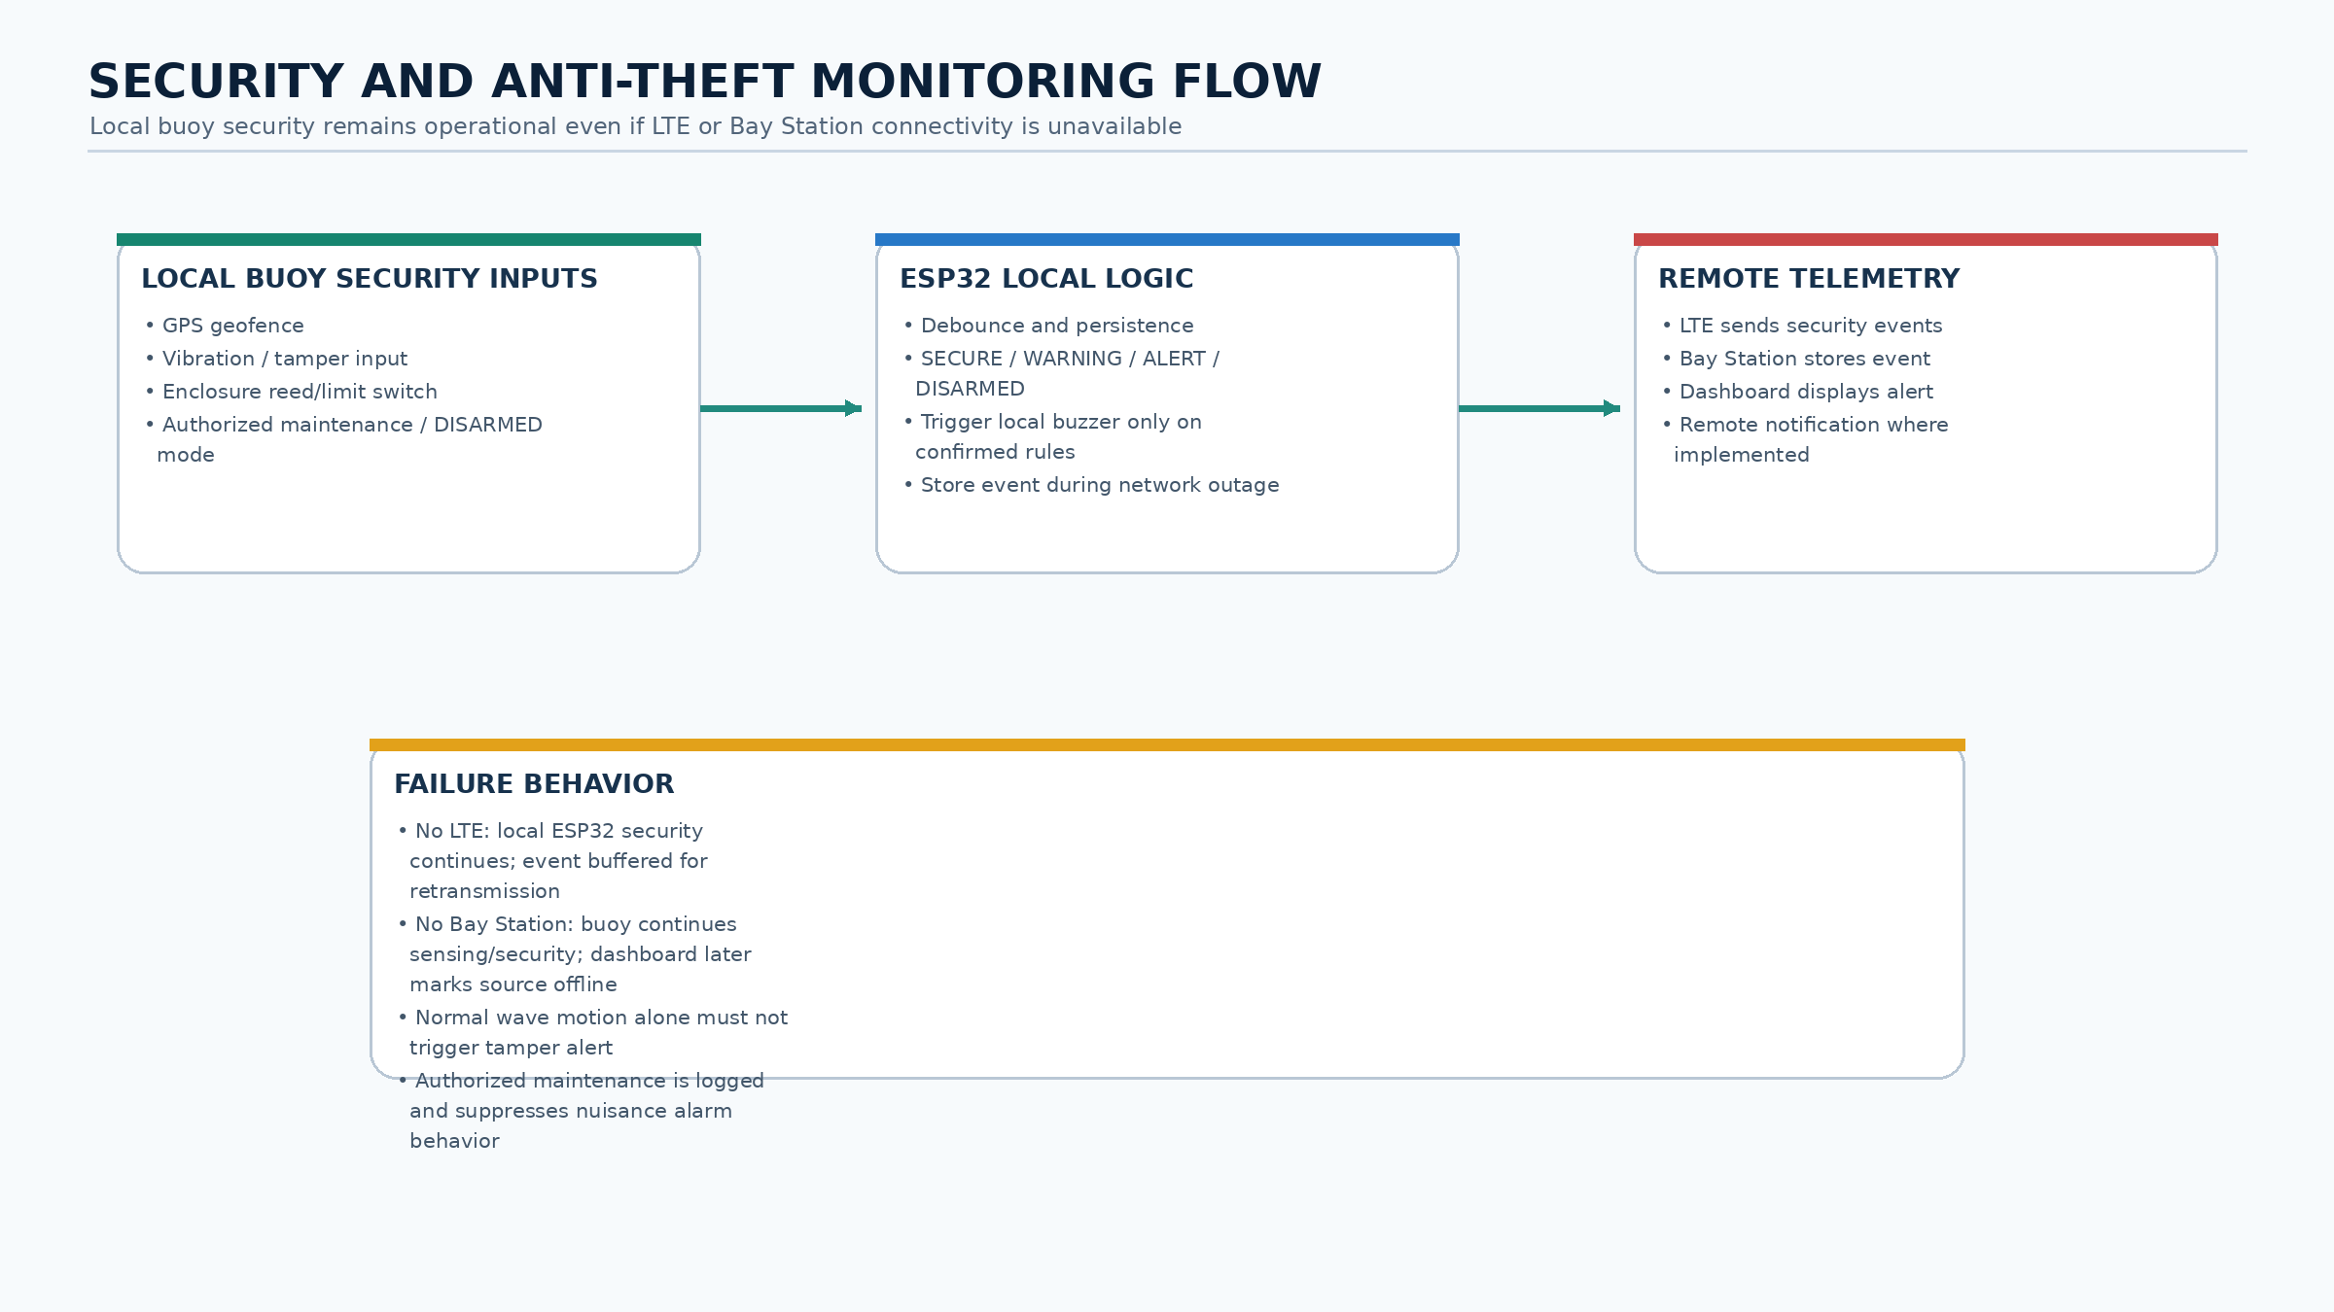

Figure 3. Detailed security and anti-theft monitoring flow.
The deployment reference coordinate and geofence radius are configuration values. A position outside the radius enters WARNING while the system evaluates fix quality and persistence. A sustained violation becomes ALERT. Vibration/tamper and enclosure-switch inputs use electrical filtering where required plus firmware debounce/persistence. Ordinary wave movement does not constitute tampering. Authorized maintenance uses DISARMED and creates an event record.
State | Meaning | Dashboard response
SECURE | Inside geofence; enclosure closed; no persistent tamper | Normal status
WARNING | Transient/uncertain event under persistence evaluation | Review message
ALERT | Persistent geofence/tamper/enclosure event | Prominent alert and buzzer rule
DISARMED | Authorized maintenance mode | Logged maintenance indicator

10. Communication, Bay Station, Software, API, AI, and Data
The ESP32 publishes versioned telemetry to the selected LTE/cellular modem/interface for transmission over an available mobile data network to the shore-based Bay Station. The exact modem protocol and network provider remain subject to component and site-coverage selection. The Bay Station mini PC receives and validates telemetry, stores original payloads and derived records in SQLite, calculates pressure-based wave estimates and current system state, persists alerts/events, serves the dashboard through a REST API, and runs the short-term wave-height prediction model. If the cellular link is unavailable, the buoy continues sensing and security functions and retains a short-term telemetry buffer for retransmission after reconnection. Satellite-to-mobile service is a fallback concept only where the selected modem/device and service are confirmed compatible.
• LIVE — connected physical source.
• SIMULATED — presentation simulator.
• ESTIMATED — derived value rather than direct measurement.
• CALIBRATION REQUIRED — no completed reference calibration.
• STALE — update age exceeds the configured limit.
• OFFLINE — source unavailable.
• OPTIONAL — nonessential feature whose failure cannot stop monitoring.

11. Dashboard Design

The operator interface uses four primary navigation pages and is served from the shore-based Bay Station. Authorized users may access it through the institution network or approved remote connection. Detailed diagnostics remain available through expandable views rather than one card per physical sensor.

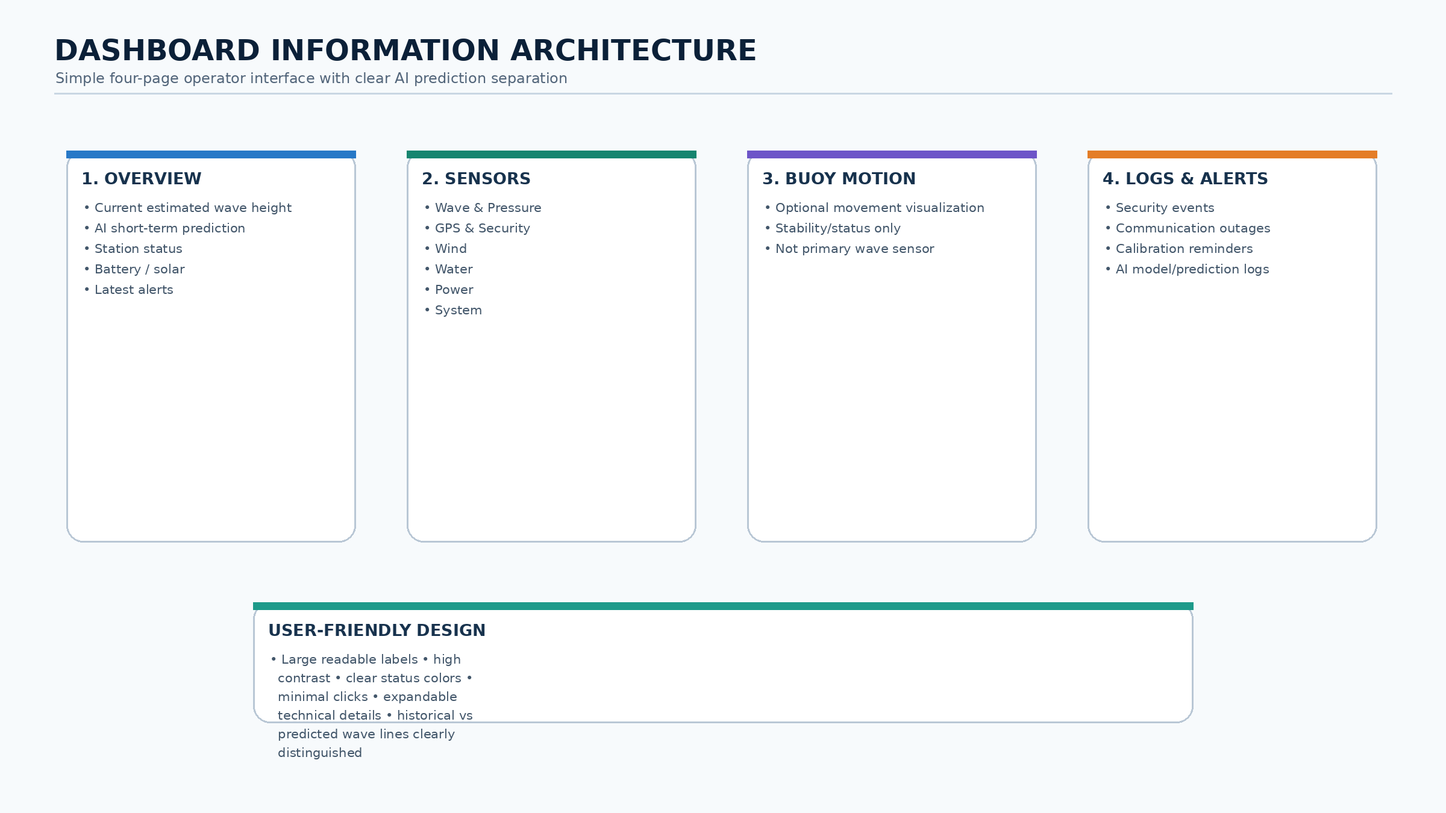

Figure 4. Simplified dashboard information architecture with grouped monitoring views and optional FALCON AI Assistant.
1. Overview: one large estimated-wave chart with a clearly labeled AI comparison line, a separate short-term prediction card, and one Station Status summary for wind, pressure, GPS security, battery, solar, and water/enclosure temperature.
2. Buoy Motion: an optional 3D visualization whose water-surface amplitude, heave, and tilt are generated from pressure-based estimated wave height. GPS supplies heading context only; no IMU, roll, or pitch sensor input is used. Current Data uses the received estimate; Calm, Moderate, Rough, and Pressure Offline are clearly labeled local presentation presets that never modify stored or live telemetry.
3. Sensors: six grouped user-facing cards—Wave & Pressure, GPS & Security, Wind, Water, Power, and System. Technical details such as exact sensor model, sampling rate, calibration state, signal quality, and update age remain available through expandable details.
4. Logs & Alerts: current warnings, security/calibration/operator events, persisted telemetry, acknowledgement, search, and export.
Settings is a compact header icon. AI short-term wave-height prediction is a core Bay Station feature. Overview uses a clearly labeled red historical AI-comparison line and a separate numeric future-prediction card so users can distinguish model output from pressure-derived estimates. The FALCON Assistant remains a separate optional user-interface aid; if enabled, it provides concise explanations of validated system states and predictions but does not control monitoring or safety functions.

12. Testing and Evaluation Plan
Test area | Evidence and metrics
Sensors | Reference comparison, range, repeatability, invalid/disconnect behavior
Wave estimate | Known reference, MAE, RMSE, bias, repeatability, calibration record
Security | Geofence accuracy, persistence, false positives/negatives, tamper/enclosure tests
Communication | Cellular packet loss, latency, coverage, reconnect time, buffered retransmission, and outage recovery
Storage/API | Bay Station retention, timestamp integrity, duplicate prevention, schema tests, restart recovery, and export verification
Power | Buoy normal/peak current, cellular transmit peaks, conversion efficiency, autonomy, charge recovery, and brownout
Dashboard | Desktop/mobile responsiveness, readability, task completion, label comprehension
Mechanical | Buoyancy, stability, water ingress, corrosion controls, mooring scope and retrieval
AI wave prediction | Chronological train/validation/test split, baseline comparison, MAE/RMSE, actual-vs-predicted plot, prediction-horizon verification

13. Risk, Ethics, and Safety
Marine deployment requires permission, site-risk review, electrical protection, waterproofing, safe battery handling, retrieval planning, and weather limits. GPS data and future camera features require privacy controls. The dashboard must state that FALCON is a research prototype and does not replace PAGASA, coast guard instructions, navigation equipment, or emergency-warning systems.

14. Current Implementation and Limitations
The repository currently includes the ESP32 firmware shell, diagnostic portal, versioned telemetry frame, Python simulator/edge service, SQLite storage, deterministic alerts, grouped API, four-page dashboard, optional pressure-driven motion visualization, and saved assistant assets. Under the revised architecture, the Python service represents the Bay Station processing role and will be extended to run the required short-term AI wave-height prediction pipeline. Physical LTE/cellular-modem integration, final mini PC deployment, and field-trained AI validation are not yet complete. Software builds and automated tests demonstrate implementation behavior only; they do not prove physical sensor accuracy, cellular coverage, prediction accuracy, or coastal readiness.
Physical pressure calibration, exact cellular modem/SIM/provider selection, supporting/security part selection, revised PCB/wiring release, Bay Station computer installation, waterproofing, onboard power autonomy, network-outage recovery testing, and controlled field trials remain pending. These limitations must remain visible in presentations, results, and conclusions.

15. Expected Output and Beneficiaries
The expected output is a documented, serviceable research prototype consisting of a low-power solar buoy sensing node and a shore-based Bay Station. The buoy provides traceable coastal readings, pressure-based estimated wave height inputs, GPS/security awareness, and cellular telemetry; the Bay Station provides persistent records, processing, alerts, and a usable dashboard. Potential Bay Station hosts include educational institutions, LGUs/DRRM offices, DOST facilities, and partner research organizations. Operational adoption requires further validation and coordination with competent authorities.

16. Development Roadmap
1. Approve exact component models and datasheets.
2. Freeze the adviser-approved electrical interfaces and revised PCB.
3. Bench-integrate Bar02, GPS, wind, DS18B20, power/security channels, ESP32, and the selected cellular modem.
4. Complete pressure/environment/security calibration and controlled reference tests.
5. Deploy and harden the Bay Station computer, database, API, dashboard services, and automatic startup/recovery.
6. Complete enclosure, solar, mooring, cellular coverage, outage-buffering, and safe controlled water trials.
7. Analyze results and revise claims based on evidence.
8. Train and evaluate the short-term AI wave-height prediction model only after sufficient calibrated field data are available; compare against a documented baseline and report MAE/RMSE on held-out data.

17. Documentation Status
This V3.7 Shore Bay Station + LTE/Cellular + AI revision supersedes conflicting V2, earlier V3, and onboard-computer descriptions. The repository master context (docs/PROJECT_CONTEXT.md) must be updated to match this split architecture. Older CAD, Wokwi, onboard-compute, motion, IMU, forecast, and PCB records may remain for historical traceability but are not the current required Phase 1 baseline unless revised and explicitly approved. The physical and visual prototype remains subject to adviser approval.

18. Pressure Sensor Installation and Reference Validation
Wave-height accuracy shall be established through comparison with an independent reference method during controlled testing. The reference may be a calibrated staff gauge/video method or another suitable reference instrument. Reference measurements must be time-aligned with the pressure data. The study will report error metrics and limitations rather than assume that pressure conversion alone is accurate.
The exact installation depth is not frozen in this document. It must be selected from the final buoy geometry, expected waterline, sensor operating range, wave conditions, and controlled test results. The installation record shall document the vertical distance from the normal waterline to the pressure-sensing element, orientation, mounting bracket, cable routing, and baseline conditions.
The pressure-sensor reference frame and mounting method remain an adviser approval gate. Controlled testing shall compare the approved buoy-mounted or stabilized mooring-referenced arrangement against an independent time-aligned wave reference. The sensor shall never hang freely; its depth, orientation, bracket, motion relative to the water surface, cable routing, and resulting measurement limitations must be documented.

19. Simplified Operator Interface and Sensor Grouping
The Sensors page does not display one card per physical device. Individual devices are grouped into six user-facing categories: (1) Wave & Pressure, (2) GPS & Security, (3) Wind, (4) Water, (5) Power, and (6) System. Expanded details preserve the underlying engineering information such as exact sensor model, sample rate, signal quality, calibration state, source, and update age.
The default operator interface is intentionally simplified for quick use by non-technical and older users. The four navigation pages are Overview, Buoy Motion, Sensors, and Logs & Alerts; Buoy Motion is explicitly optional visualization. Important information should be understandable with minimal clicking, large readable labels, high contrast, and clear status colors.
The FALCON Assistant may be used as a user-friendly dashboard overlay that explains validated system states, alerts, and AI prediction output in short language. It shall not create independent safety decisions, alter sensor measurements, or replace the dedicated wave-prediction model.

20. Literature Basis for Pressure-Based Wave Estimation
The pressure-based method is supported by established wave-measurement literature. Bishop and Donelan (1987) showed that subsurface pressure measurements can be converted into wave information while emphasizing that pressure attenuation, sensor depth, and wave frequency require correction. Bonneton et al. (2018) further demonstrated reconstruction of free-surface elevation from subsurface pressure using a depth-aware nonlinear method. Ardhuin et al. (2019) emphasized that platform response, sensor characteristics, sampling, and processing affect reported sea-state estimates.
For Project FALCON, these studies justify using underwater pressure as the primary wave input while also requiring a documented installation depth, calibration, signal processing, and reference comparison. The thesis therefore reports pressure-based estimated wave height rather than claiming direct professional-grade wave-height measurement.

21. Reference Literature Added for the Revised Wave Method
Bonneton, P., Lannes, D., Martins, K., & Michallet, H. (2018). A nonlinear weakly dispersive method for recovering the elevation of irrotational surface waves from pressure measurements. Coastal Engineering, 138, 1–8. https://doi.org/10.1016/j.coastaleng.2018.04.005
Bishop, C. T., & Donelan, M. A. (1987). Measuring waves with pressure transducers. Coastal Engineering, 11(4), 309–328. https://doi.org/10.1016/0378-3839(87)90031-7
Ardhuin, F., Stopa, J. E., Chapron, B., Collard, F., Husson, R., Jensen, R. E., Johannessen, J., Mouche, A., Passaro, M., Quartly, G. D., Swail, V., & Young, I. R. (2019). Observing sea states. Frontiers in Marine Science, 6, Article 124. https://doi.org/10.3389/fmars.2019.00124

22. Buoy Power Architecture and Bay Station Separation
The power subsystem is separated into two domains. The buoy solar/battery system supplies only the ESP32, sensors, LTE/cellular modem, security electronics, and required auxiliary loads. No mini PC is installed on or powered by the buoy. The mini PC is located at the shore-based Bay Station and uses facility power or a separately designed backup/UPS. Final panel rating, MPPT model, battery capacity, modem power behavior, converter ratings, fuse values, and wire gauges must be frozen only after exact component selection and measured daily energy testing.
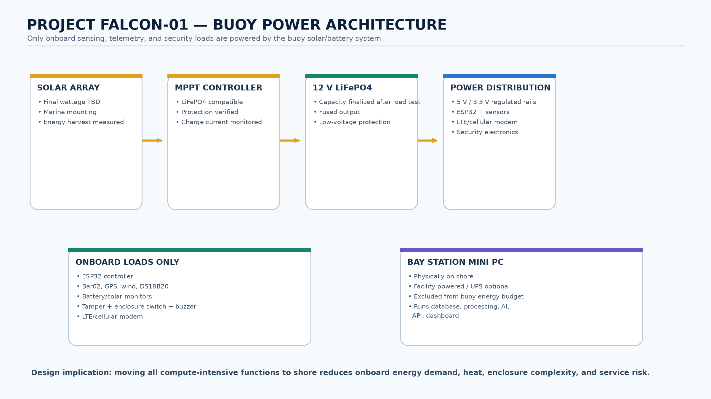

22.1 Provisional Electronics Consumption
The following values are provisional design envelopes and planning assumptions, not measured continuous consumption. Final values shall be replaced by a 24-hour current log covering ESP32 operation, sensor sampling, LTE/cellular registration and transmission peaks, security electronics, optional auxiliary loads, and idle periods. Bay Station mini PC consumption is measured separately because it is shore powered.
Load | Preliminary electrical basis | Documentation status
ESP32 + complete sensor carrier | Regulated low-voltage branch; exact continuous/peak draw measured after final hardware selection | Measure ESP32 plus all installed sensors during idle and active sampling
Cellular modem + antenna | Separate design allowance; registration and transmit peaks must be measured from selected modem | Measure idle, network registration, reconnect, and telemetry transmit current
Optional enclosure fans / auxiliary | Included only if final thermal testing requires them | Do not include if shore-computer removal eliminates the thermal need
Pressure, GPS, wind, water, power, and security sensors | Included in ESP32/sensor branch | Record exact idle/active current from purchased datasheets and bench measurements
Bay Station mini PC | Facility powered; excluded from buoy solar/battery budget | Measure separately for facility power/UPS planning

22.2 Battery Capacity and Autonomy
The provisional baseline remains a 12.8 V, 20 Ah LiFePO4 battery (256 Wh nominal). Using an 80% usable-energy planning limit gives 204.8 Wh. Because the buoy contains only the ESP32, sensors, LTE/cellular modem, security electronics, and power-conversion loads, final runtime shall be recalculated from their measured average consumption. The shore-based mini PC is excluded from all buoy runtime calculations.
Complete average load | Daily energy | Estimated no-solar runtime
2 W | 48 Wh/day | 102.4 hours
4 W | 96 Wh/day | 51.2 hours
6 W | 144 Wh/day | 34.1 hours

22.3 Solar-Panel Sizing
Preliminary daily harvest uses panel rating × 4 peak-sun-hours × 70% net system efficiency. The 70% factor provisionally covers MPPT, wiring, conversion, temperature, orientation, and contamination losses; actual deployment conditions must be logged. Since the compute-intensive mini PC is shore based, the buoy solar system is sized only for sensing, LTE/cellular telemetry, security, and power conversion. No panel reduction shall be finalized until transmission peaks and 24-hour energy use are measured.
Solar option | Estimated harvest | Interpretation
40 W nominal panel | 112 Wh/day | Possible reduced-load option; suitable only if measured onboard average load and modem peaks provide adequate margin
60 W nominal panel | 168 Wh/day | Stronger prototype starting point pending measured cellular telemetry load and site conditions
LiFePO4-compatible MPPT | Exact model TBD | Panel Voc/Isc, charge profile, current rating, thermal behavior, and protection must be verified
These calculations are provisional sizing values, not validated endurance claims. Do not approve unattended deployment until the buoy passes a 24-hour onboard load measurement, cellular transmission peak/brownout tests, and at least a 72-hour solar-endurance trial. The Bay Station must be tested separately for service recovery, storage continuity, network availability, and backup-power behavior where applicable.
Figure 5. Buoy-only solar power architecture: ESP32 + sensors + LTE/cellular modem + security electronics; Bay Station mini PC is shore powered.

23. End-to-End Data and Failure Handling
Every telemetry record must preserve its source, timestamp, validity, calibration state, and freshness. Missing or invalid measurements are reported as unavailable rather than silently replaced with zero. The ESP32 continues sensor acquisition and local security logic if cellular connectivity or the Bay Station is unavailable. A short-term local buffer preserves recent telemetry for later retransmission. The Bay Station stores received records, detects delayed/stale sources, and reconciles buffered telemetry after reconnection without silently duplicating records.
Required data-state behavior: LIVE for connected physical data, SIMULATED for presentation sources, ESTIMATED for derived quantities, CALIBRATION REQUIRED where reference calibration is incomplete, STALE when update age exceeds the configured limit, OFFLINE when the source is unavailable, and OPTIONAL for nonessential features.

24. Functional and Non-Functional Requirements
The following minimum requirements provide traceability between the thesis objectives, software implementation, and evaluation plan.
ID | Requirement | Acceptance evidence | Priority
FR-01 | Acquire and timestamp core sensor channels on ESP32. | Bench log with valid engineering units and stale/disconnect behavior. | Required
FR-02 | Estimate wave height from calibrated underwater-pressure variation. | Controlled reference comparison with MAE, RMSE, bias, and repeatability. | Required
FR-03 | Persist telemetry and events on the shore-based Bay Station. | SQLite retention, duplicate-prevention, restart recovery, and export test. | Required
FR-04 | Provide GPS geofence and tamper/enclosure state logic. | SECURE/WARNING/ALERT/DISARMED scenario tests and false-alert record. | Required
FR-05 | Provide simplified four-page browser dashboard. | Desktop/mobile usability and task-completion test. | Required
FR-06 | Provide audible buzzer only under confirmed security rules. | Controlled alert test and maintenance/disarm verification. | Required
FR-07 | Provide short-term AI wave-height prediction at the Bay Station. | Held-out evaluation versus persistence/baseline using MAE, RMSE, and actual-vs-predicted plots. | Required
NFR-01 | Continue onboard sensing/security during Internet outages and recover buffered telemetry after reconnection. | Disconnect/reconnect test with timestamp-preserving buffered retransmission and no silent data fabrication. | Required
NFR-02 | Fail visibly and safely. | Invalid values show STALE/OFFLINE/UNCALIBRATED, never fabricated zeroes. | Required
NFR-03 | Remain serviceable and maintainable. | Documented connectors, mounting, waterproofing checks, and retrieval procedure. | Required
FR-08 | Acquire sealed-probe water temperature with explicit validity and freshness states. | DS18B20 reference comparison, stale/disconnect tests, and correct dashboard labels. | Required

25. Controlled Deployment and Validation Workflow
Testing proceeds from component selection to bench integration, calibration, controlled failure tests, water trials, telemetry validation, AI dataset preparation, baseline comparison, held-out prediction testing, and evidence-based revision of claims.
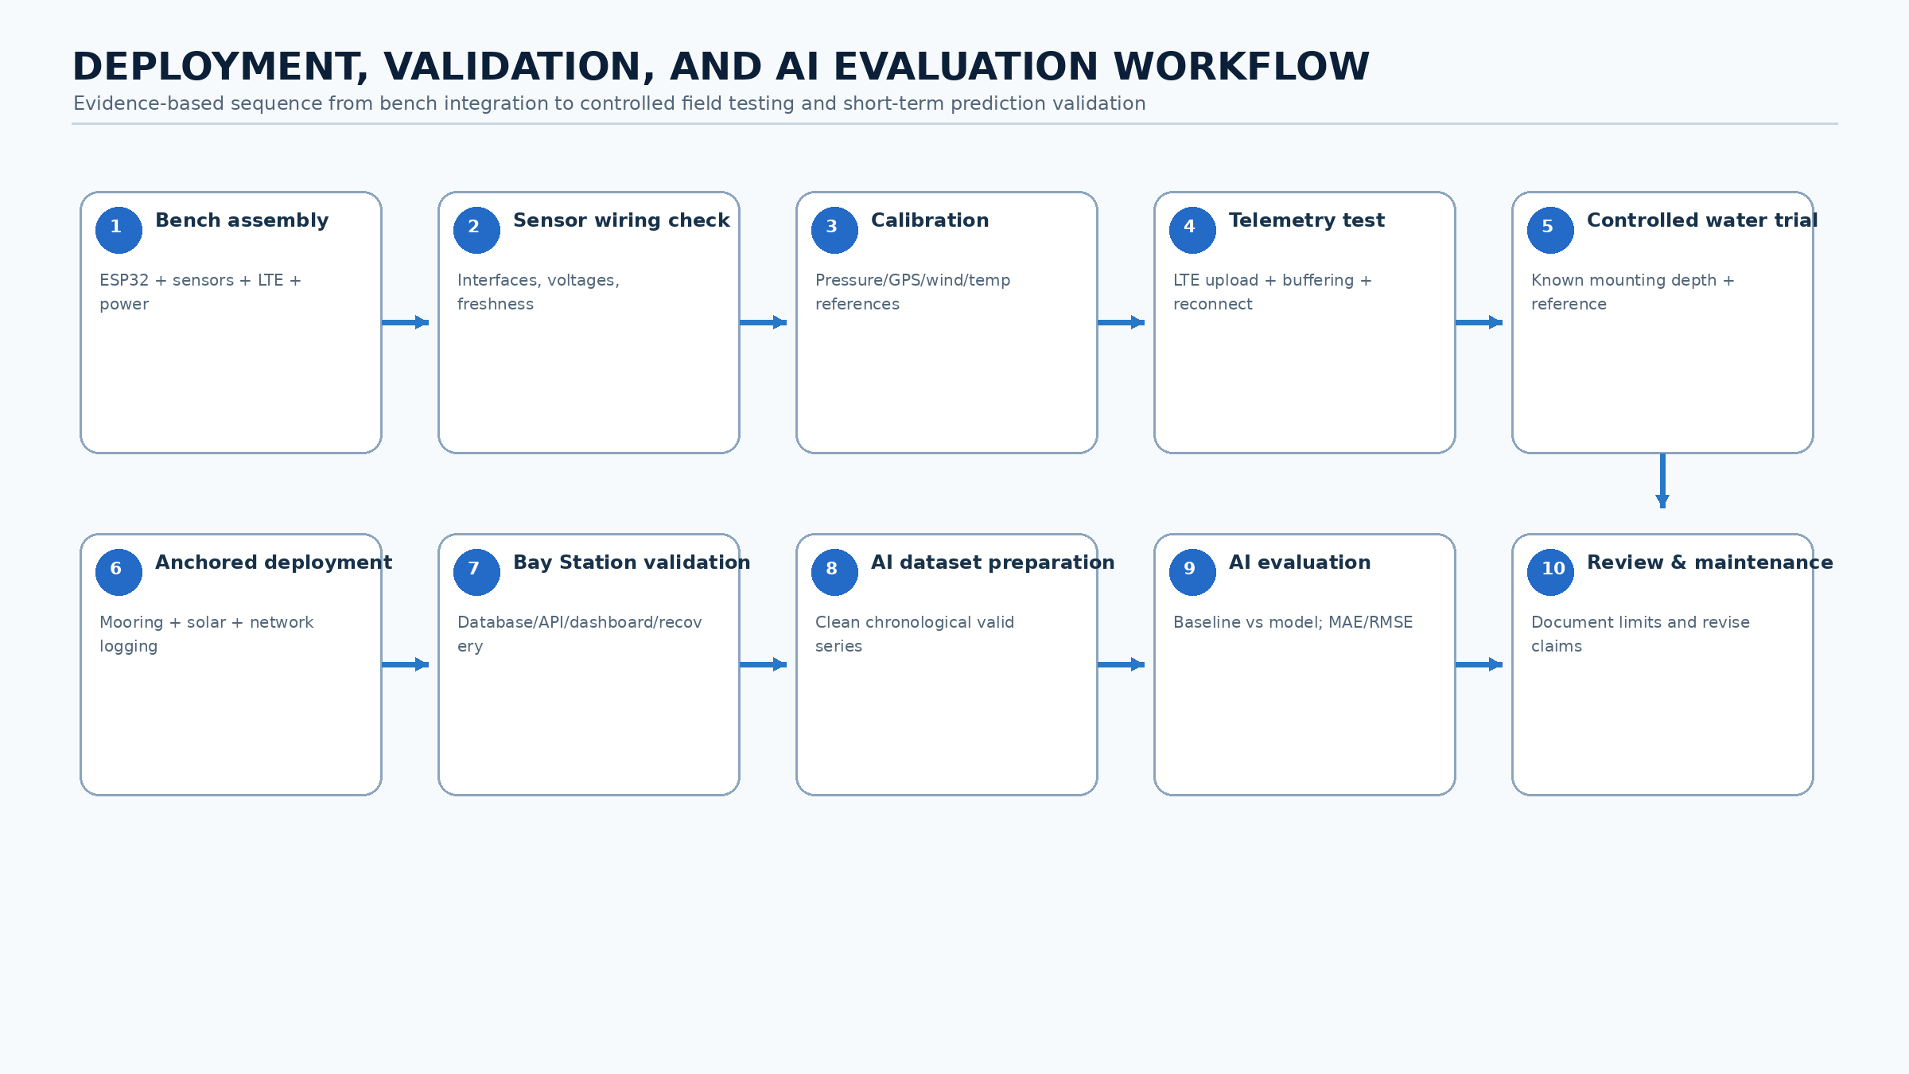
Figure 6. Detailed deployment, calibration, validation, and maintenance workflow.

26. System Flow Summary
The following concise flow should be used consistently in presentations, diagrams, and implementation notes:
Sensors → ESP32 acquisition/validation → LTE/cellular modem / available mobile network → Internet → shore-based Bay Station mini PC → storage + pressure processing → AI short-term wave-height prediction → REST API/dashboard + alerts → user. During link outages, the buoy continues sensing/security and temporarily buffers data for later upload. The FALCON Assistant may explain system and prediction states but does not control the sensing, security, or AI prediction pipeline.

27. Design Decisions Requiring Final Adviser Approval
The following items remain intentionally unresolved and should not be treated as final until exact hardware, datasheets, fabrication constraints, site coverage, and controlled tests are available: exact GPS model; exact wind-speed and wind-direction sensor models; tamper sensor type; enclosure switch and buzzer electrical ratings; pressure-sensor mounting depth; LTE/cellular modem model; antenna type and placement; SIM/network provider; satellite-to-mobile compatibility if pursued; Bay Station mini PC model; Bay Station hosting site; short-term buffer implementation; solar-panel rating; MPPT model; battery capacity; converter and fuse ratings; final PCB connectors and pinout; mooring line material/length/scope; independent wave-reference method; AI feature set; prediction horizon; training dataset size; baseline model; and final AI model architecture.

Appendix A — Approved Telemetry Sections
• system
• wave
• environment
• gps
• power
• security
• health
• assistant
• alerts

Appendix B — Immediate Documentation Records Required
• Exact component and supplier register
• Sensor calibration sheets
• Pressure installation-depth and baseline record
• GPS geofence configuration and test record
• Tamper/enclosure debounce and false-alert record
• Power-load and autonomy worksheet
• Waterproofing and pre-deployment checklist
• Controlled-test dataset and analysis
• Dashboard usability/readability test record for non-technical users
• Pressure-sensor mounting-depth, bracket, and reference-validation record

